NUMERICAL INTEGRATION
- TRAPEZOIDAL RULE
AIM: TO WRITE A PROGRAM IN PYTHON TO DEMONSTRATE TRAPEZOIDAL RULE.
PROGRAM:
# Trapezoidal Rule for I = integral(f(x) dx from 0 to 1) with 2 subintervals

def f(x):
"""The integrand: 1 / (1 + x^2)"""
return 1 / (1 + x**2)

# Given limits
a = 0
b = 1
n = 2 # number of subintervals

# Step size
h = (b - a) / n

# Compute x values
x = [a + i * h for i in range(n + 1)] # [0.0, 0.5, 1.0]

# Compute f(x) values
f_values = [f(xi) for xi in x] # [1.0, 0.8, 0.5]

# Display table header
print("-----------------------------------")

print("i | x(i) | f(x(i)) = 1/(1+x^2)")
print("-----------------------------------")
# Display table values
for i in range(n + 1):
print(f"{i:<3} | {x[i]:<8.4f} | {f_values[i]:<8.4f}")
print("-----------------------------------")

# Apply Trapezoidal Rule
# The formula in Python: I = (h / 2) * (f[0] + 2 * sum(f[1:-1]) + f[-1])
I = (h / 2) * (f_values[0] + 2 * sum(f_values[1:-1]) + f_values[-1])

# Step-by-step explanation
print(f"h = (b - a) / n = ({b} - {a}) / {n} = {h}")
print("\nUsing Trapezoidal Rule:")
print(f"I = (h / 2) * [f(x0) + 2*f(x1) + f(x2)]")
print(f"I = ({h/2}) * [{f_values[0]:.4f} + 2*{f_values[1]:.4f} + {f_values[2]:.4f}]")

# Final result
print("\n-----------------------------------")
print(f"Approximate value of the integral I = {I:.4f}")
print("-----------------------------------")
OUTPUT:
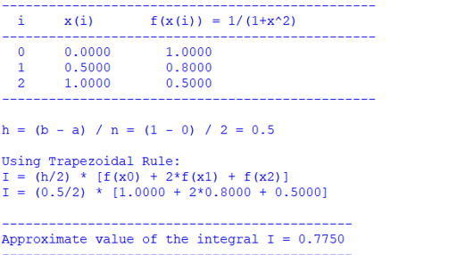
CONCLUSION: THE ABOVE PROGRAM HAS BEEN EXECUTED SUCCESSFULLY.

